VIRUSES

User Guide

|  |  |  |
| --- | --- | --- |
| Supervisor. | Miss Maryam |  |
| Batch. | 2510E1 |  |
| Group. | A |  |
| Serial No. | Enrollment Number | Student Name |
| 1. | Student1700392 | ABDULLAH AHMED |
| 2. | Student1698784 | RAYYAN TARIQ |
| 3. | Student1700387 | JUNAID ASLAM |
| 4. | Student1698786 | SYED SAFDAR HUSSAIN RIZVI |

**1. Welcome (index.html)**

**Figure 1: Welcome Page to VIRUS Tech**

The home page introduces users to the world of viruses and provides high-level navigation to the platform's educational resources.

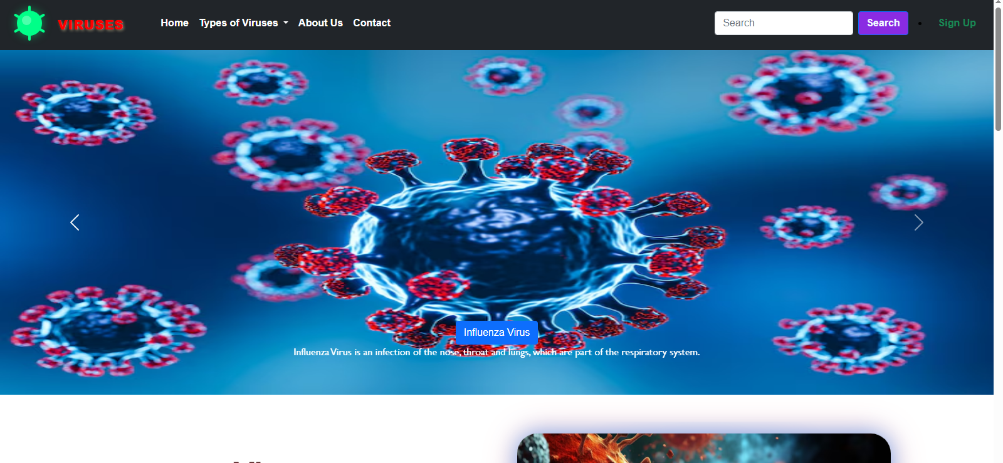

**2. Layout Top & Navigation**



The navigation bar is used to access the various informational pages across the site:

* **Home:** Returns the user to the main landing page.

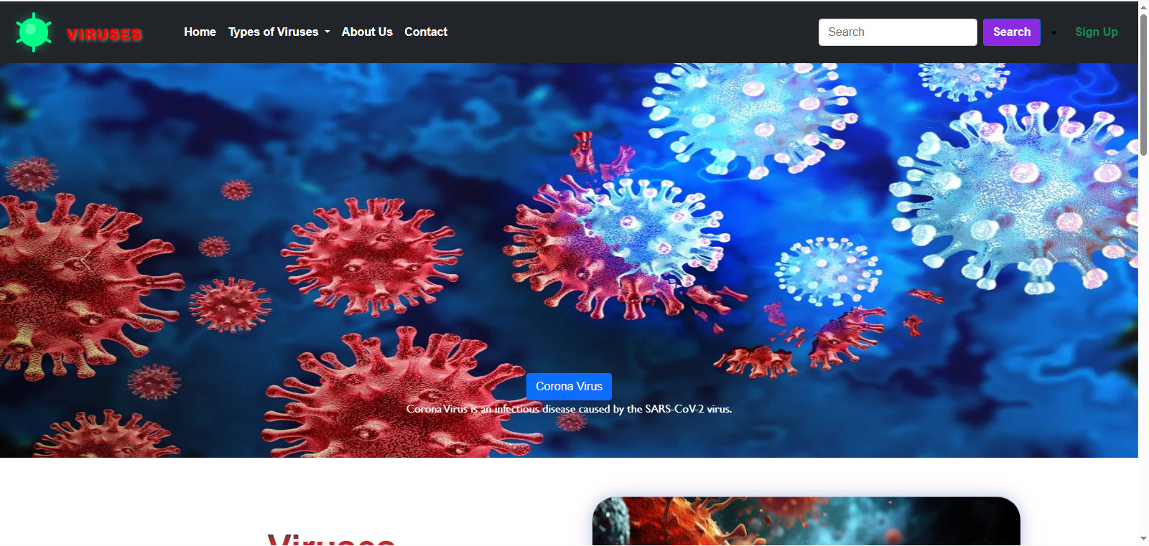

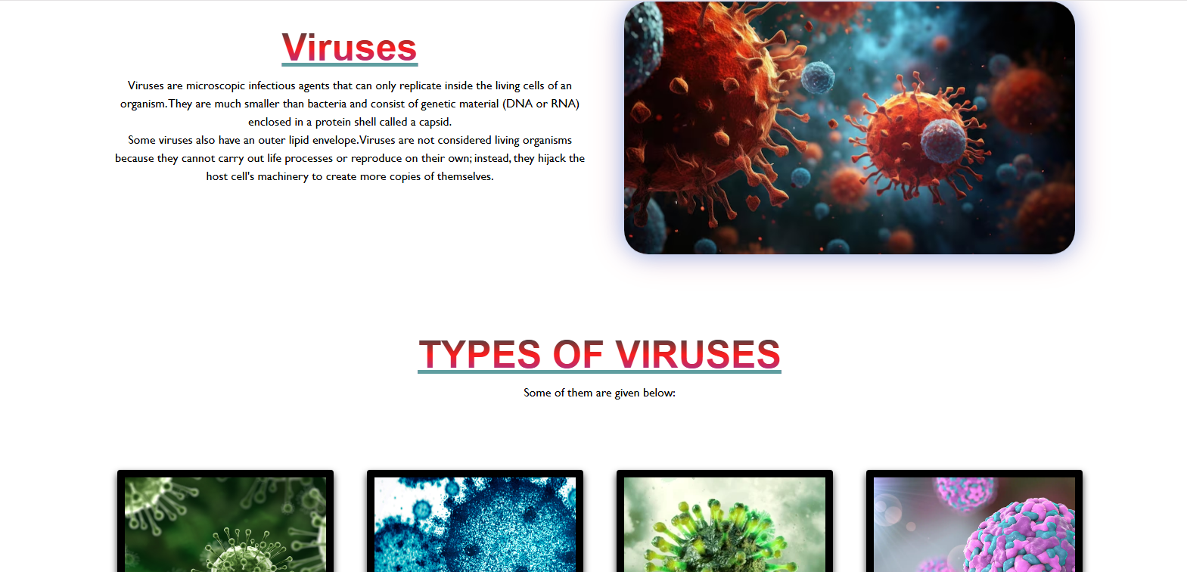

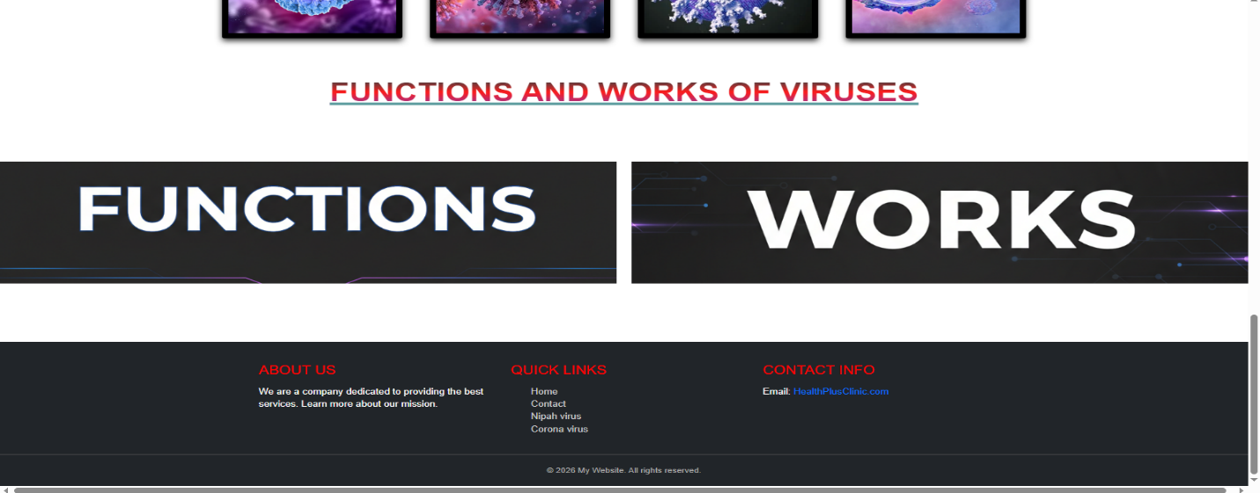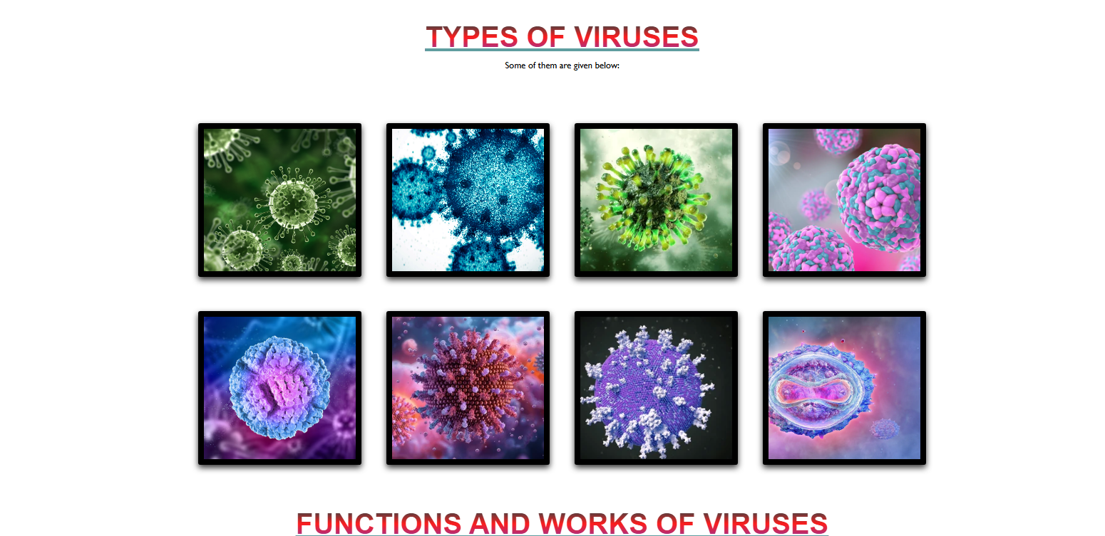

* **About Us:** Provides information about the VIRUS Tech team and their mission.

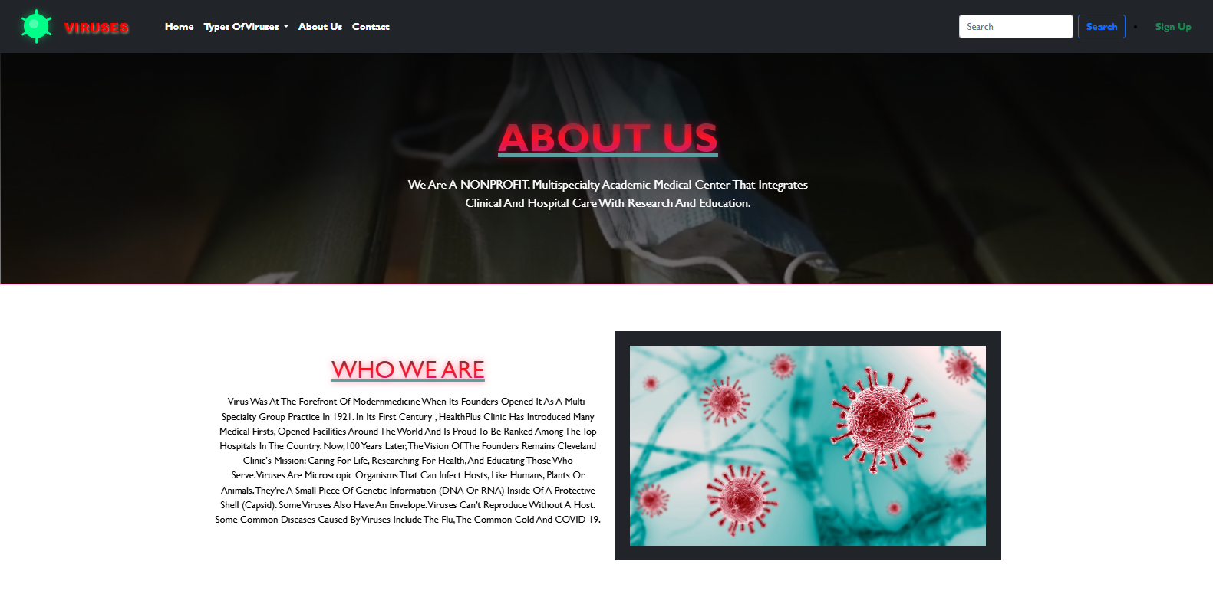

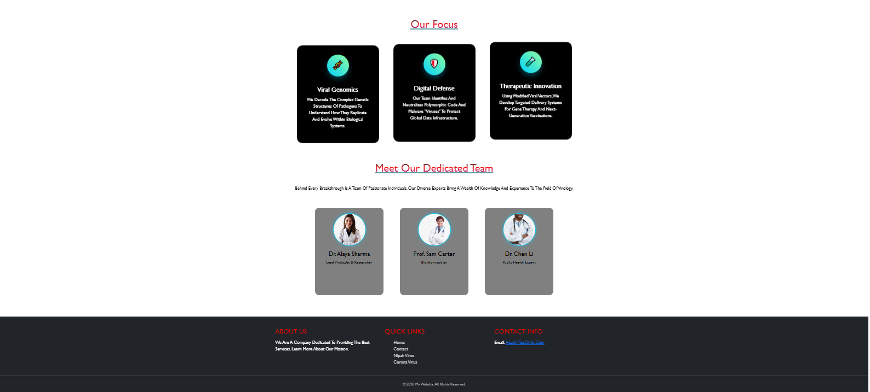

* **Contact:** Leads to the contact form and clinic location details.

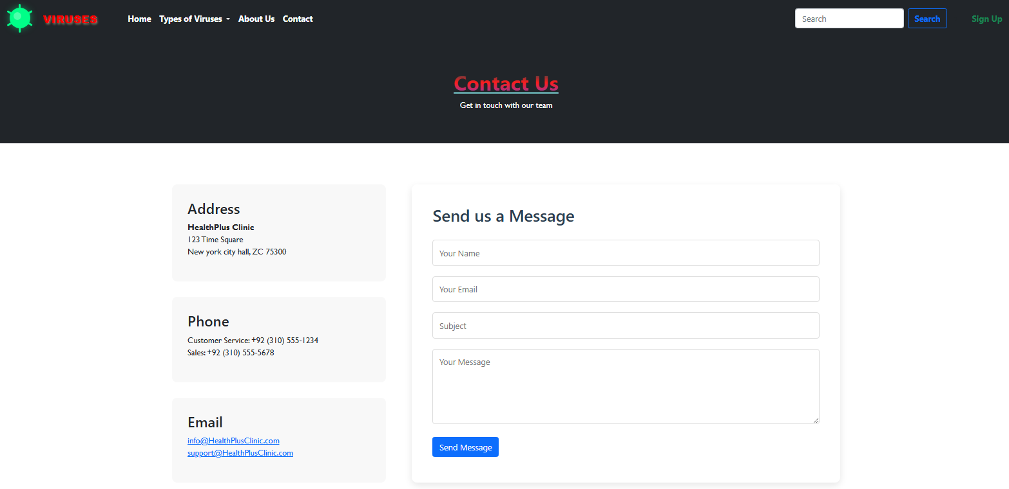

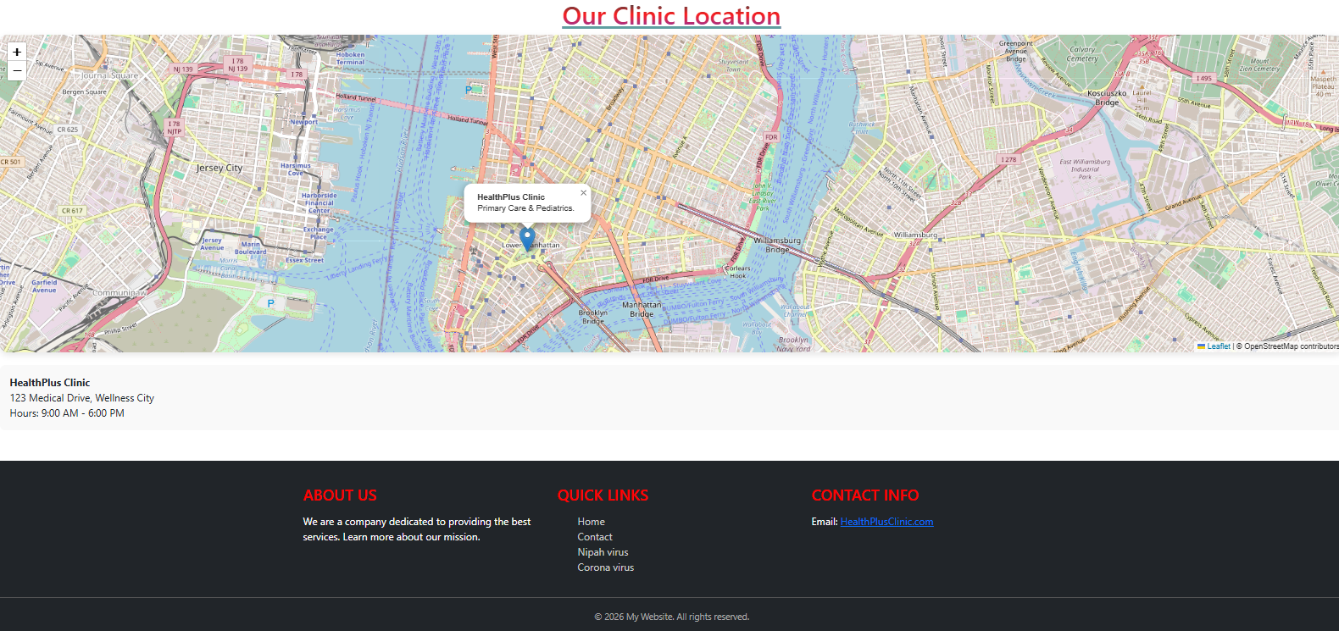

* **Virus Database (Dropdown):** Provides direct links to specific virus information pages.

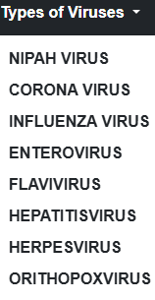

**3. Virus Information Modules**

The website contains detailed modules for several viral categories. Each page includes biological information, transmission details, and prevention methods.

**3.1 Corona Virus (coronavirus.html)**

Focuses on respiratory transmission and the importance of vaccination.

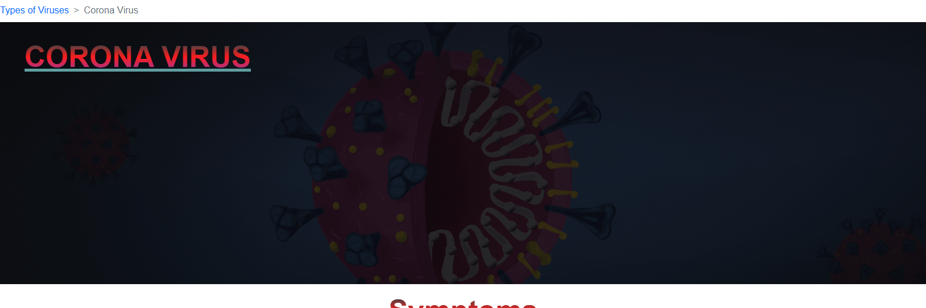

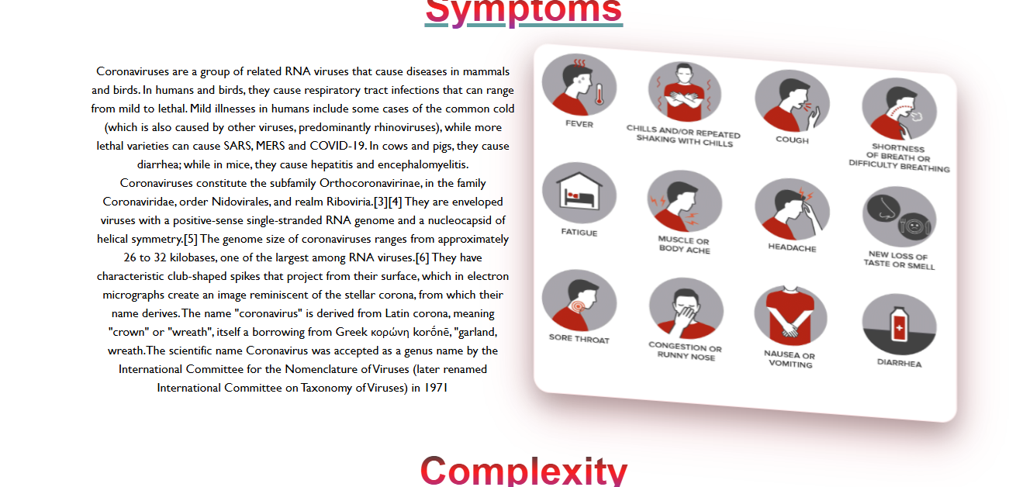

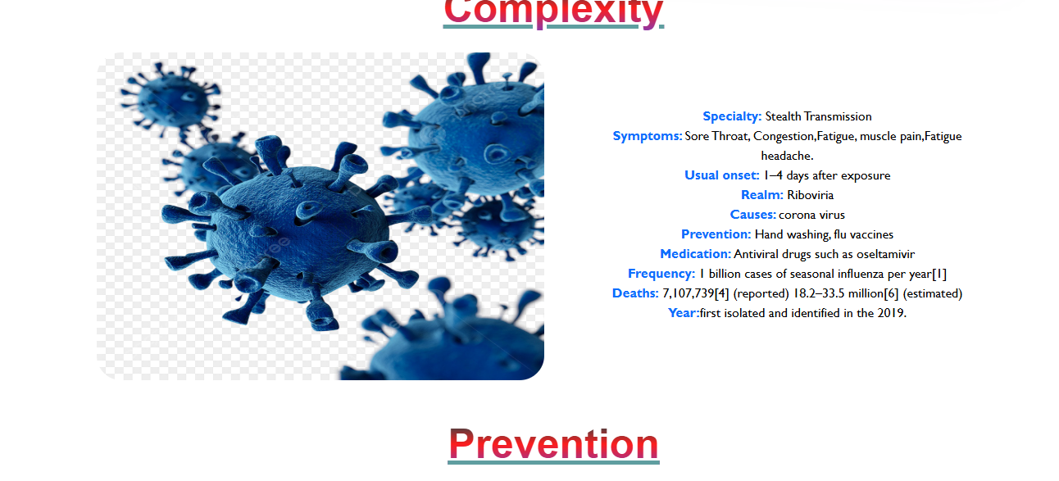

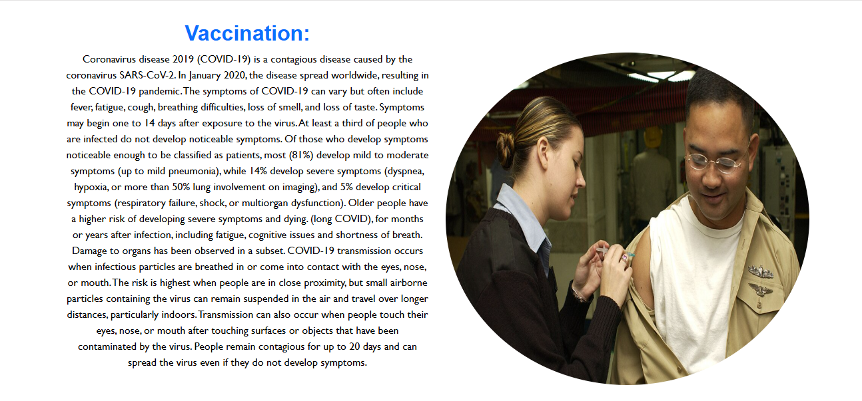

**3.2 Enterovirus (enterovirus.html)**

Discusses pathogens emerging in the mid-20th century, such as EV-70.

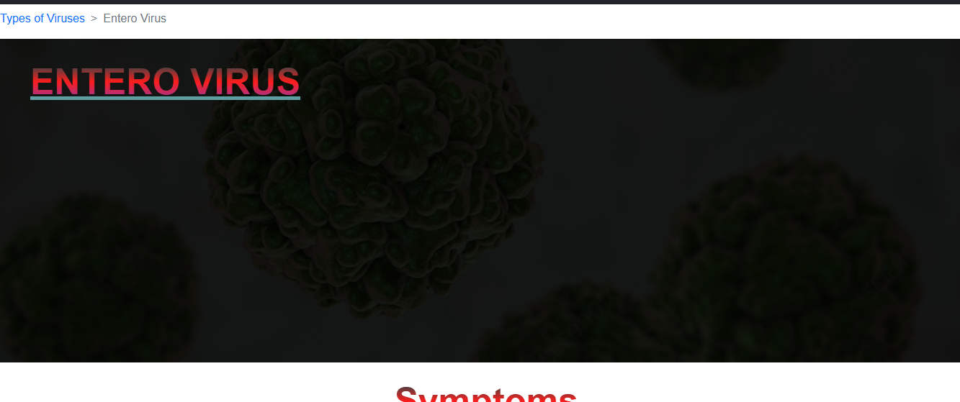



**3.3 Flavivirus (flavivirus.html)**

Covers mosquito-borne illnesses and prevention strategies like maintaining water storage and using fine mesh screens.

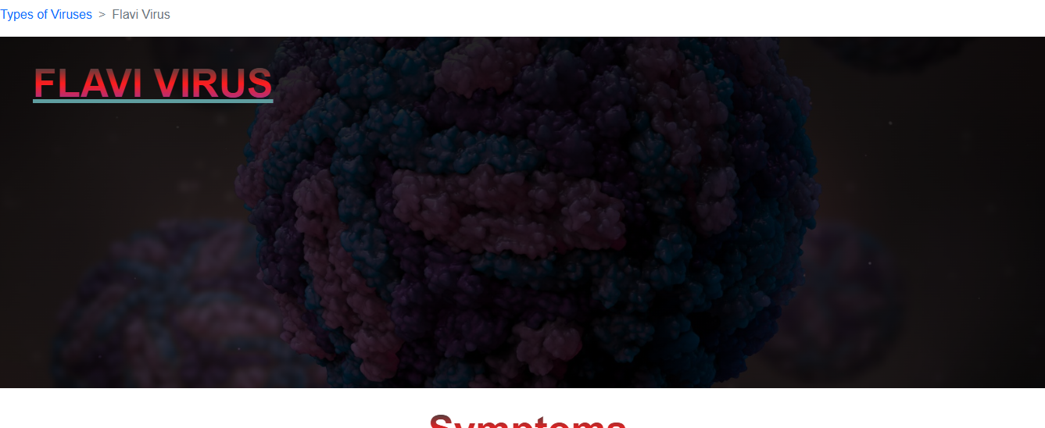



**3.4 Hepatitis Virus (hepatitisvirus.html)**

Provides information on liver-affecting viruses and the Twinrix combination vaccine.

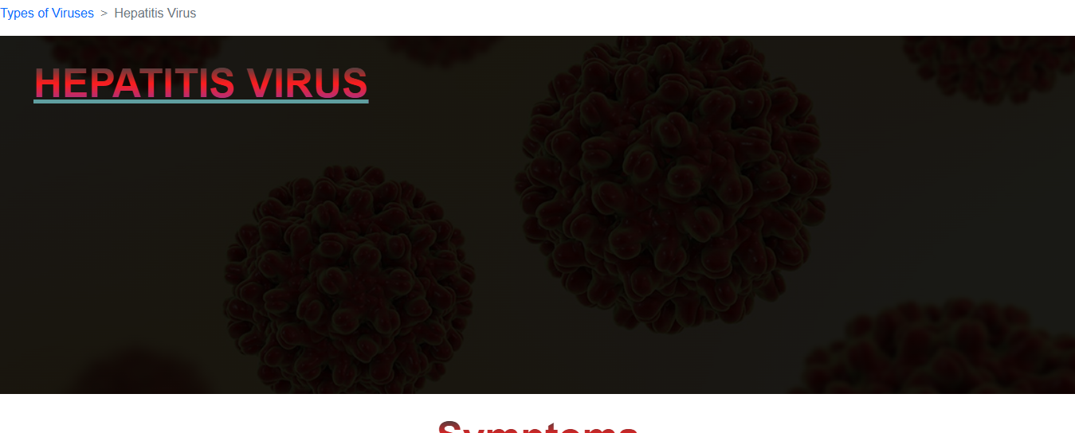



**3.4 Herpesvirus (herpesvirus.html)**

Outlines the history and manifestations of the virus, including respiratory tract cases.

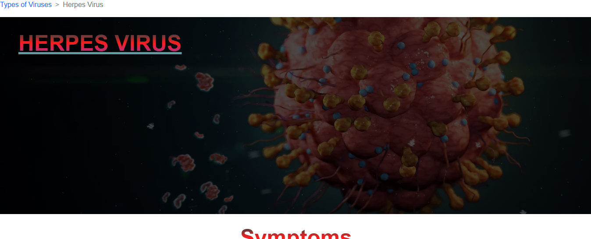



**4. Support and Contact**

**Figure 3: Contact Interface**

* **Contact Info:** Users can reach the team via email.

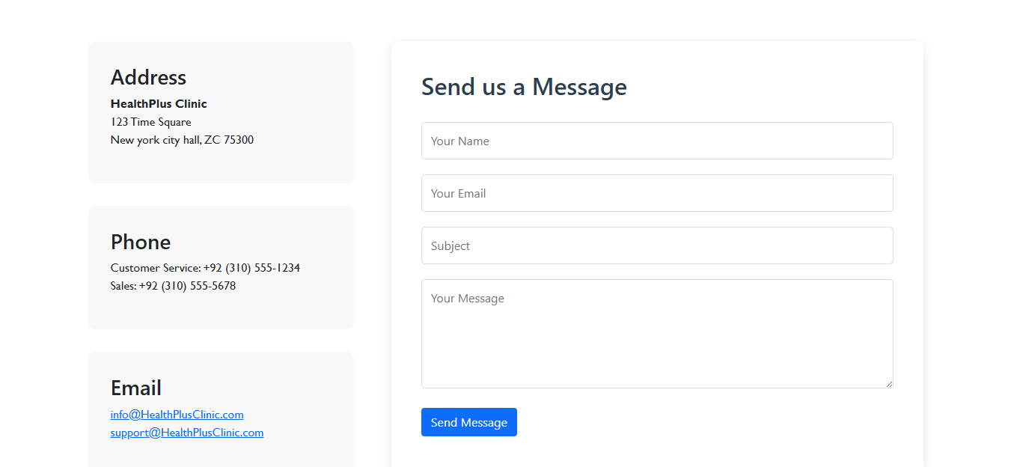

* **Location:** Includes an interactive map for the physical clinic located at 123 Medical Drive.

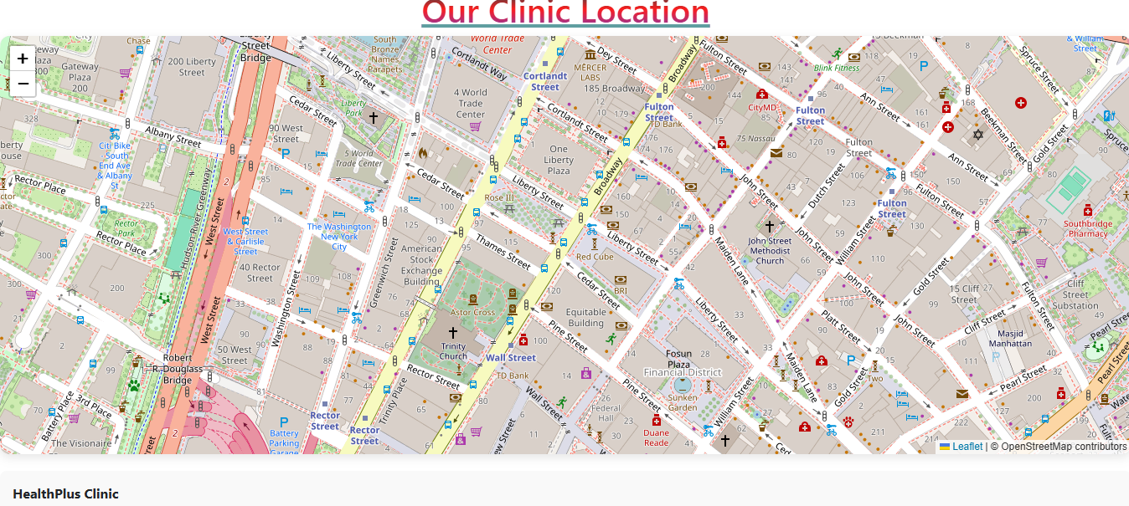

* **Quick Links:** A footer section available on every page for easy site navigation.

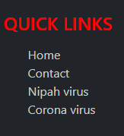

**5. Layout Bottom**

**Figure 4: Layout Bottom**

The footer displays:

* **About Us Summary:** Mission statement of the company.
* **Quick Links:** Navigation to Home, Contact, Nipah Virus, and Corona Virus pages.
* **Copyright:** © 2026 My Website. All rights reserved.

